Agile Model

What is Agile ?

Agile is a process by which a team can manage a project by breaking it up into several stages and involving constant collaboration with stakeholders and continuous improvement and iteration at every stage. This clarifies the customer's expectations to the project team.
Agile Methodology

Agile methods or Agile processes generally promote a disciplined project management process that encourages frequent inspection and adaptation, a leadership philosophy that encourages teamwork, self-organization and accountability, a set of engineering best practices intended to allow for rapid delivery of high-quality ...
Purpose of Model
The overall goal of each Agile method is to adapt to change and deliver working software as quickly as possible. However, each methodology has slight variations in the way it defines the phases of software development. Furthermore, even though the goal is the same, each team’s process flow may vary depending on the specific project or situation. As an example, the full Agile software development lifecycle includes the concept, inception, construction, release, production, and retirement phases.
The four values of the Agile Manifesto
The Agile Manifesto consists of four key values:
1.Individuals and interactions over processes and tools.
2.Working software over comprehensive documentation.
3.Customer collaboration over contract negotiation.
4.Responding to change over following a plan.
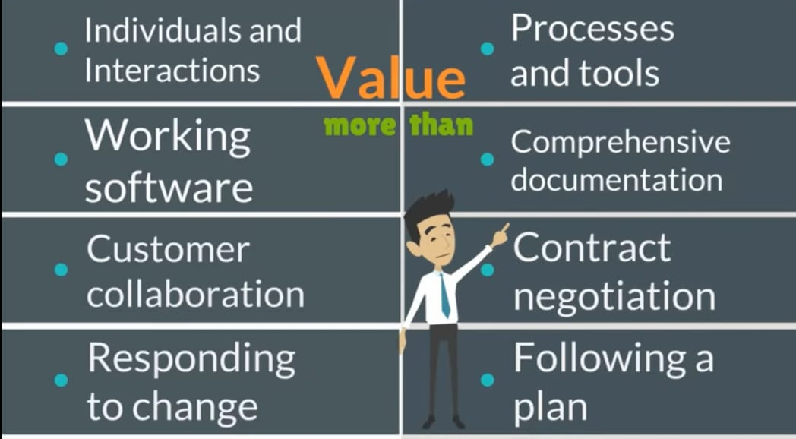

The Agile Lifecycle
There are a variety of Agile software development (or system development) methodologies, including, but not limited to:
It is a family of iterative , incremental methods.
1.Disciplined Agile Delivery (DAD)
2.Adaptive Software Development
3.Agile Modeling
4.Kanban
5.Scrum
6.Scrumban
7.Extreme Programming (XP)
8.Dynamic Systems Development (DSDM)
9.Feature Driven Development
10.Lean Software Development

A typical iteration process flow can be visualized as follows:
Requirements - Define the requirements for the iteration based on the product backlog, sprint backlog, customer and stakeholder feedback
Development - Design and develop software based on defined requirements
Testing - QA (Quality Assurance) testing, internal and external training, documentation development
Delivery - Integrate and deliver the working iteration into production
Feedback - Accept customer and stakeholder feedback and work it into the requirements of the next iteration
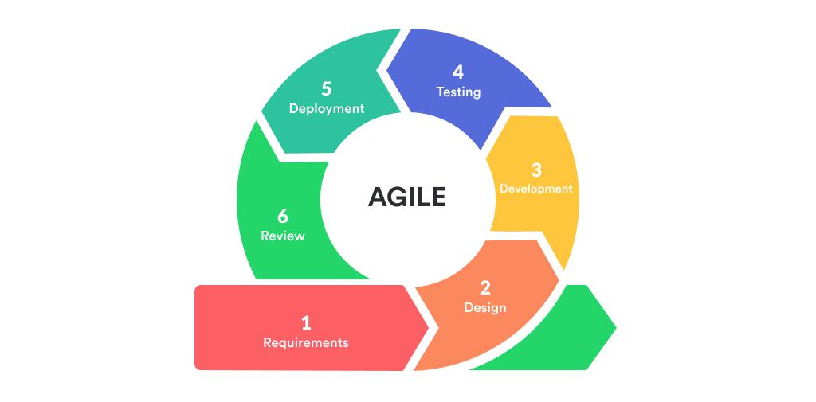

Agile iteration workflow diagram
For the duration of the project, while additional features may be fed into the product backlog, the rest of the process is a matter of repeating the steps over and over until all of the items in the product backlog have been fulfilled. As a result, the process flow is more of a loop and not a linear process.

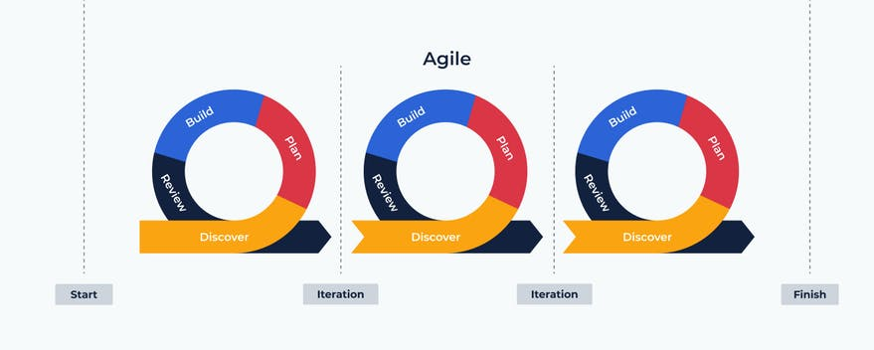

Advantages of Agile Methodology
1.Customer satisfaction is rapid, continuous development and delivery of useful software.
2.Customer, Developer, and Product Owner interact regularly to emphasize rather than processes and tools.
3.Product is developed fast and frequently delivered (weeks rather than months.)
4.A face-to-face conversation is the best form of communication.
5.It continuously gave attention to technical excellence and good design.
6.Daily and close cooperation between business people and developers.
7.Regular adaptation to changing circumstances.
8.Even late changes in requirements are welcomed.

Disadvantages of Agile methodology:

- There is a lack of intensity on necessary designing and documentation.
- It requires an expert project member to take crucial decisions in the meeting.
- Cost of Agile development methodology is slightly more as compared to other development methodology.
- The project can quickly go out off track if the project manager is not clear about requirements and what outcome he/she wants.
- It is not useful for small development projects.
Realtime Examples
we can use this
1. JIRA
2.SCRUM
3.Software Development ()

